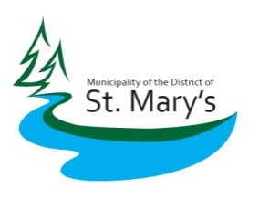
Municipality of the District of St. Mary’s
8296 Highway 7 Sherbrooke NS B0J 3C0

Service Announcement: Update on municipal waste disposal services
Update: Due to recent changes in provincial regulations by the Department of Environment and Climate Change regarding the disposal of Construction and Demolition Waste (C&D), the municipality is suspending the acceptance of Construction and Demolition Waste, effective beginning January 12, 2024, until further notice.
Details: Construction and Demolition will be the only services affected. Specifically, this means that all waste from home or building demolition and renovations will not be accepted at this time.
All other municipal waste services, including services provided via the Municipal Transfer Station and all curbside collection services, including bulky item collection will continue as normal.
Next Steps: The municipality recognizes and understands the need for an easy-to-access service for the handling of renovation and construction demolition debris. We are actively working to identify solutions and timelines to implement solutions to resume related services. We apologize for any inconvenience this may cause.
Questions: For additional information regarding the Municipal Transfer Station, please contact The Municipal Office at (902)522-2049 or email council@saint-marys.ca
FYI Background: The suspension of C&D disposal services is needed to allow the municipality to adapt to new provincial environment standards. C&D waste is stored in buried cells at waste sites such as the municipal transfer station. Constructing and managing waste storage cells in the ground that will meet the new environmental requirements represents a significant change to our processes, and time is needed to develop a cost-effective new way to receive and store materials.
Sincerely,
The Municipality of the District of St. Mary’s.

