OLD ROAD HILL NEIGHBOURHOOD CONCEPT PLAN
PROJECT DESIGN STATEMENT

The Municipality transforms its housing commitment into concrete action with the unveiling of a groundbreaking project that reimagines a 50-acre parcel of Municipally owned land as a complete, intergenerational community in the Village of Sherbrooke. Developed through extensive engagement with community members, this plan sets the vision for a new community in the Municipality of the District of St. Mary’s created with and for residents.

Please click the Link or visit: St. Mary's Old Road Hill Presentation (zzap.ca) to see the full concept plan unveiling presentation with visuals.

Vital Statements derived out of discussions with community and drove key elements of the plan:

- Housing variety is essential, but the focus should be on affordability, accessibility, and sustainability. The plan predominantly uses a compact, consistent unit footprint that can be clustered and stacked in different arrangements. This provides variety in scale and housing types, encourages the supply of accessible single-level units for seniors, and can still accommodate two-level and single-level units targeted at workers and families. At the same time, it also allows for the economies of scale associated with “cookie cutter” development and enables creative design and construction approaches such as pre-approved building designs and modular construction which reduce the time and cost of delivering housing.
- Care facilities are a part of a complete community. A proposed 48-bed long-term care facility is integrated into the core of the community, ensuring residents remain connected to the communities and people they know as their care needs expand. Neighboring buildings include a future hospital facility and Community Wellness Centre to provide wrap-around care services that go beyond traditional healthcare. While these facilities serve community, in turn, the staff become a key part of the community itself, creating demand for walkable housing, rental units, and drawing young people and families to the area.

- Community design should create moments of connection. The development is anchored by a central intergenerational park, located at the natural “point of connection” created by surrounding recreational and institutional uses. This park supports users of all ages and abilities by offering a mix of passive and active recreation facilities linked to a network of trails and pedestrian connections through the neighbourhood.
- Growth should be used to protect and enhance natural spaces. Located adjacent the beautiful scenery of Stonewall Park and St. Mary’s River, denser housing forms (including duplexes, townhouses, and multis) provide significant housing while minimizing disturbance to the site and supporting investment into enhancing existing park assets, including a provision of a new park entrance to Stonewall Park.
- Sustainable design is about more than the environment. The site design incorporates sustainable design elements as not just necessary environmental features, but community assets. This includes the layout, which maximizes South facing exposure as development moves up the hill to support the integration of rooftop solar to combat both climate change and energy poverty. It also includes the network of existing and new trail systems throughout the community which not only reduce car use and related emissions, but also increase accessibility, save residents money, and promote an active, healthy lifestyle.
Quote from Warden Wier

Warden Greg Wier emphasized the urgency and significance of this initiative. "Housing is a fundamental human right, and it is our responsibility as a Municipality to ensure that every possible policy and financial commitment is in place to accelerate residents’ access to a decent and affordable place to live. Council’s commitment to housing is not just about providing a roof over people's heads, but also about creating a more equitable and sustainable community for all."

Warden Wier reiterated the commitment on behalf of Council by stating "We've committed to challenge the housing crisis, and now, with the community, we're excited to shift from dialogue to action. St. Mary’s is ready for concrete solutions, and that's exactly what we're providing."

Additional Information (Q&A):
Question: Why this property and location?
Answer: The property is owned by the Municipality, and it is near power, water and sewer. The property is located by an abundance of services such as a grocery store, bank, retail, drug store, restaurants, hardware and medical services co-located with the hospital. The Property Identification Number is 37501095.
Question: Does this mean the Municipality is building housing?
Answer: No, the Municipality will not be building, owning or managing any housing in the new
neighbourhood. We aim to create partnerships with housing developers and nonprofit housing organizations to support their building, owning or management of housing.
Question: Why Is the Municipality reserving this land for housing?
Answer: The Municipality owns the land and has determined that a vibrant neighbourhood could address several needs that St Mary’s is facing. The location of the property is optimal due to proximity to amenities and utilities.
Answer: Further, the Municipality will be formally inviting the province to consider working with the municipality to locate the recently announced new long-term care facility to be developed for Sherbrooke in this location. We feel we can offer an ideal place for the new home as part of this concept while also helping facilitate the redevelopment of the home
Answer: Further the municipality also plans to reserve part of the subject land for a potential future site of a new local hospital. There are no stated provincial plans for such. The municipality feels we have an opportunity help future planning for local medical service by thinking ahead.

Question: How does this impact Sherbrooke?
Answer: The aim of the municipality is to have a concept plan those compliments, enhances and strengthens Sherbrooke and St. Mary’s as a desirable place to live, play and work.
Answer: We hope that more residents would support local business by way of more local customers

Question: what is the right size of an additional development for Sherbrooke and St. Mary’s. Is this big enough or too big?

Answer: We know there is a significant need for housing here. We don’t know how much is needed. It is important to cover future potential coupled with the goal of having large green spaces and room for both future long term care homes and maybe a future hospital. Most importantly, this is long term, multi-year planning. Things will happen as needed. It’s very likely that we will find new needs as we go especially new asks identified by our residents and we need the ability to react.

Question: What about stonewall park?

Answer: The areas commonly known as stonewall park with be carefully preserved. In fact, the planning is to make better walkable and useable park spaces crossing the lands and better connecting new buildings and homes with Old Road Hill

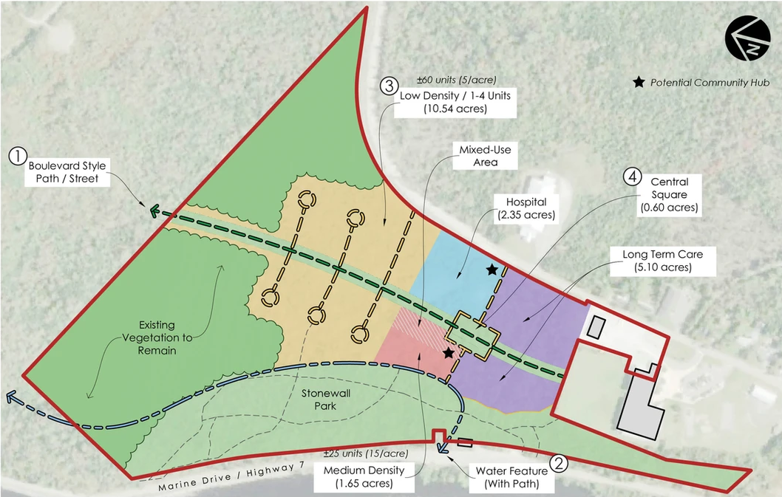

MEDIA CONTACT:
Doug Patterson
Chief Administrative Officer
doug.patterson@saint-marys.ca 902-522-2049

