FOR IMMEDIATE RELEASE
October 30th, 2024
Announcing the New Municipality of the District of St. Mary’s Council
Sherbrooke, Nova Scotia – The Municipality of the District of St. Mary’s is excited to announce the formation of the new Municipal Council, aimed at enhancing community engagement, improving local policies, etc. This council will play a crucial role in shaping the future of our community through housing initiatives, economic development, and recreational activities.
The Municipality of the District of St. Mary’s Council is composed of 5 dedicated members. District 1: Councillor, Emma Tibbo
District 2: Councillor, Dana O’Connell
District 3: Deputy Warden, Beulah Malloy
District 4: Councillor, Scott Beaver
District 5: Warden, James Fuller
Together, they bring a wealth of experience in the community, organizations, etc. and are committed to working collaboratively to address the needs and concerns of our community.
The inaugural meeting of the Municipal Council has taken place on October 30th, 2024, at 4:00 pm in the Council Chambers. We invited all residents to join us and share their thoughts and ideas.
Council nominated and then appointed Councillor James Fuller (District 5) as Warden, and Councillor Beulah Malloy (District 3) as Deputy Warden. Council agreed to set the Terms of Warden and Deputy Warden for 2 years.
If you are interested in listening to the inaugural meeting that took place October 30th, 2024, you can visit: www.saint-marys.ca

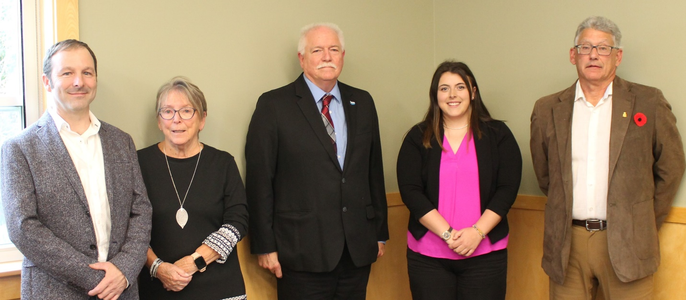
Image from left to right: Councillor Scott Beaver, Deputy Warden Beulah Malloy, Warden James Fuller, Councillor Emma Tibbo, and Councillor Dana O’Connell.
For more information about the Municipality of the District of St. Mary’s Council and staff please visit www.saint-marys.ca
Media Contact:
Doug Patterson
Chief Administration Officer
The Municipality of the District of St. Mary’s
902-522-2432
doug.patterson@saint-marys.ca

